Weekly reports are to be emailed to atbecker@uh.edu by 5:00pm on Tuesdays. The purpose of a weekly report is to: (1) give you text and images for your papers, thesis, and dissertation, (2) document progress, (3) identify if you are stuck or need resources.

Weekly report

1. **My *Goals* from last week**

* Make even more version 4 magnetic sliders once more magnets come in.
* Make the large tilt table sturdier and less flexible.
* Work with Arun to make one of the tables useful for his demonstrations.

1. **My *Accomplishments* this week**
   1. Project 1: <1’x 2’ Parts Bin Tilt Table Sturdier>

* No new files.
* Since the acrylic of the table was so long and thin the tilt table would bend when held at the ends so I added an extra sheet beneath it with holes cut in the same spots as the original table so that the long plastic pegs of the stop block will sink all the way down and hold the two sheets of acrylic together. I may make the connection more permanent using the acrylic glue but as of now it holds together fine.
  1. Project 2: <Added Gears to Servo Stand. >
     + DWG files for 2 to 1 gears and updated servo stand to work with gears.

<https://github.com/aabecker/LaserCutter3DPrinter/blob/master/LaserCutter/Designs/Jarrett%20Lonsford/2to1_servo%20gears.dwg>

<https://github.com/aabecker/LaserCutter3DPrinter/blob/master/LaserCutter/Designs/Jarrett%20Lonsford/Tilt_Table_Stand_V2.dwg>

* + - I added a two to one gear ratio to the servo stand to try and fix a couple of issues I was having with it. One of these issues was that the table would rotate too fast at times and cause pieces to move when the table is moving back to parallel. Adding the gears has slowed down the table’s rotation and lessened this problem. Another issue was that getting small precise angle rotations, like 15 degrees, with the servo is nigh impossible. But now with the gears added I can rotate the table 15 degrees by rotating the servos 30 degrees which they can easily achieve. I also added some extra support pieces to the servo shafts to reduce the amount of “wiggle” with the gears.

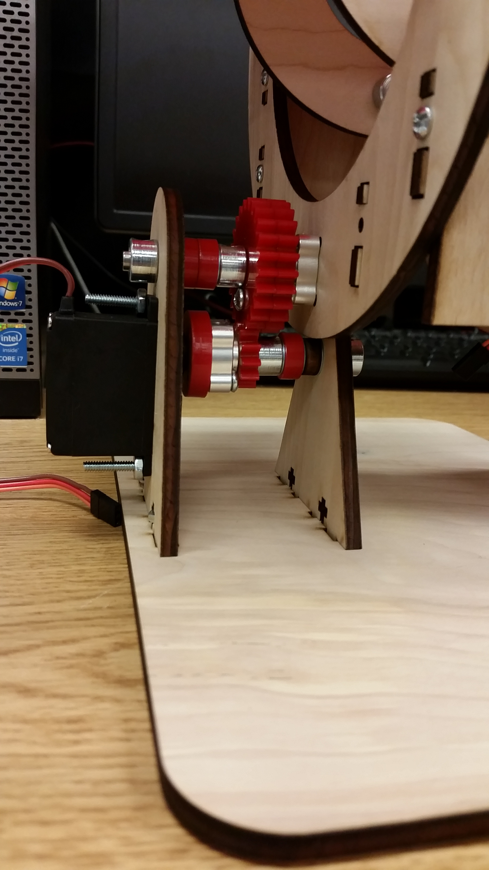

**Figure 1:** Lower servo and gears.

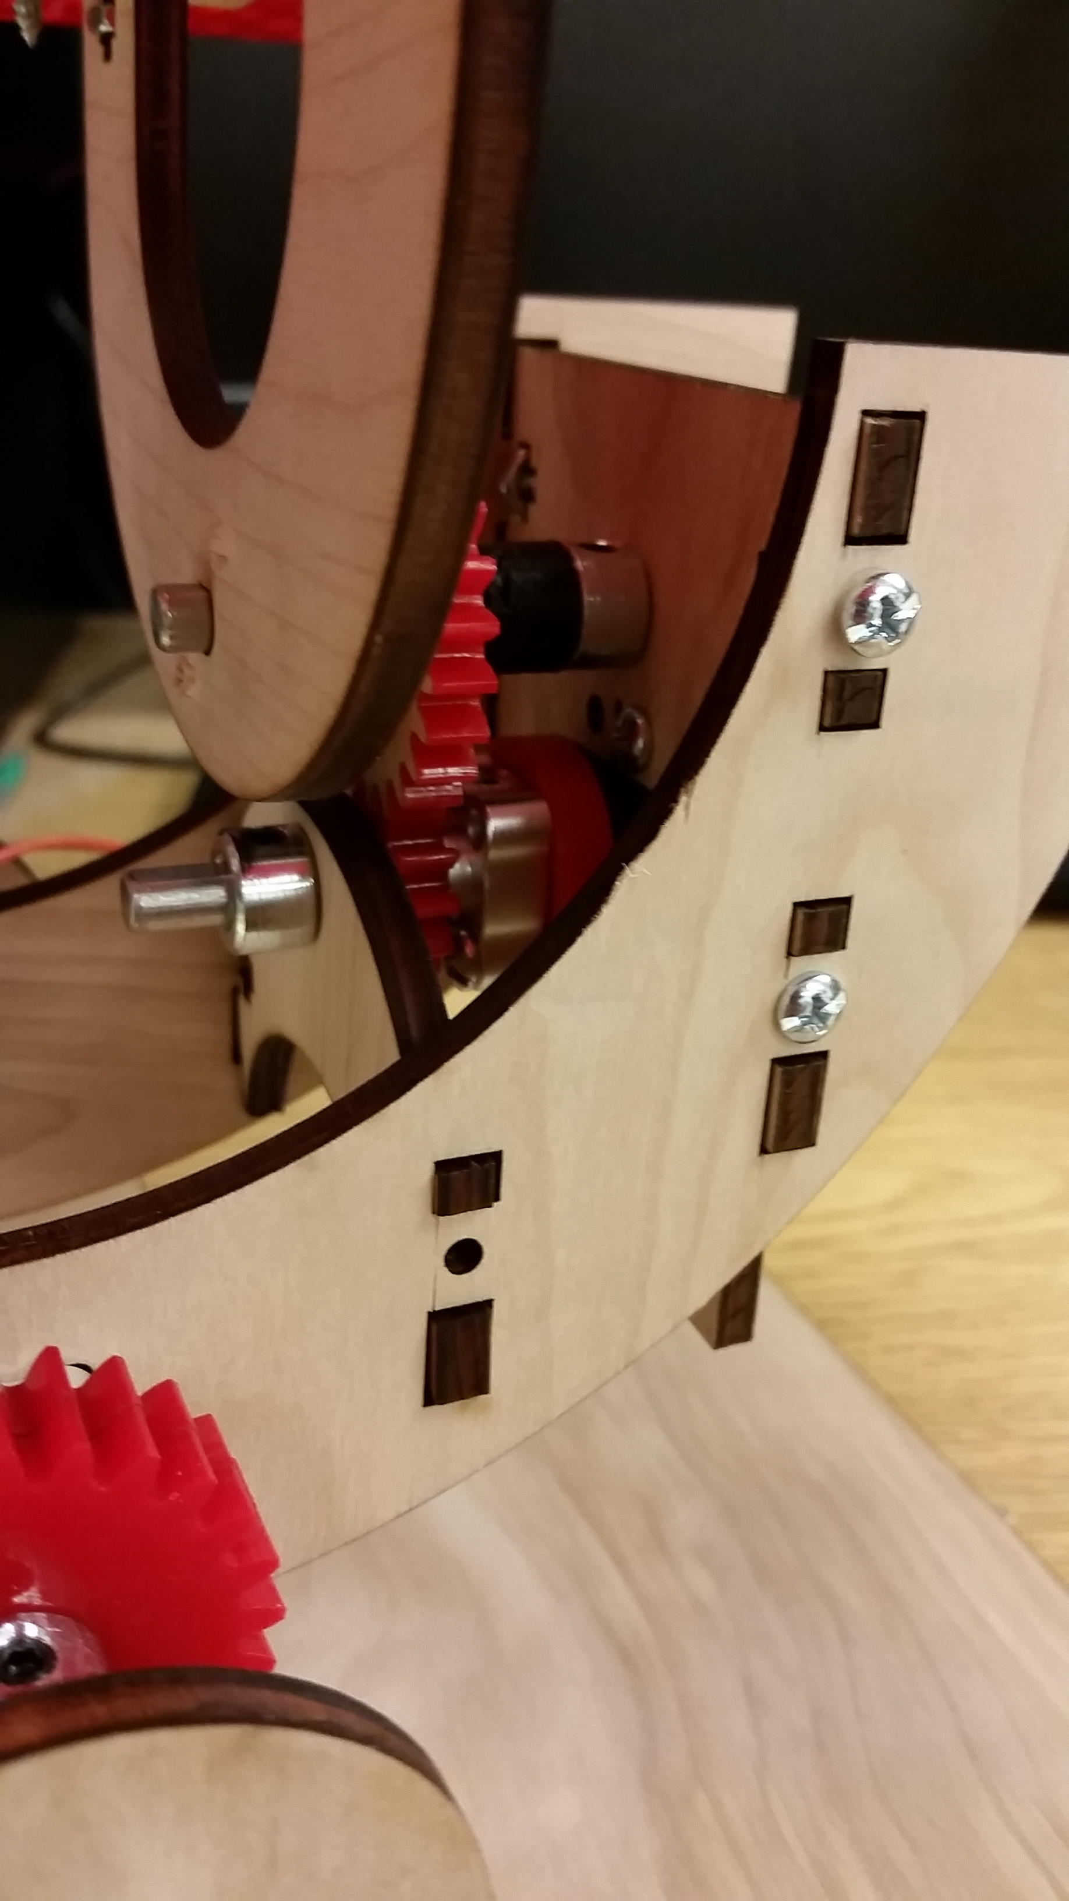

**Figure 2:** Upper servo and gears.

* 1. Project 3: <Maintenance on the 3D printer.>
* After several failed prints An and I began trying to figure out why the printer was having issues. When An was out I found that part of the issue was that the feeder motor was chewing up the material, possibly because the feeder was overheating, or the feeder mount needed to be cleaned or the tension was too high (the tension was at the lowest setting). When looking up solutions to this problem I came across a new design for the feeder mount that is more open and much easier to clean and you can easily see when something is going wrong with the feeder. I used the larger 3D printer to print out this alternate feeder design and then An and I replaced the Ultimaker’s feeder. While we can now more easily adjust the tension on the feeder the print quality is still fairly poor, although it is actually printing now. An is still working on these issues with the printer and I will help him when I have time.

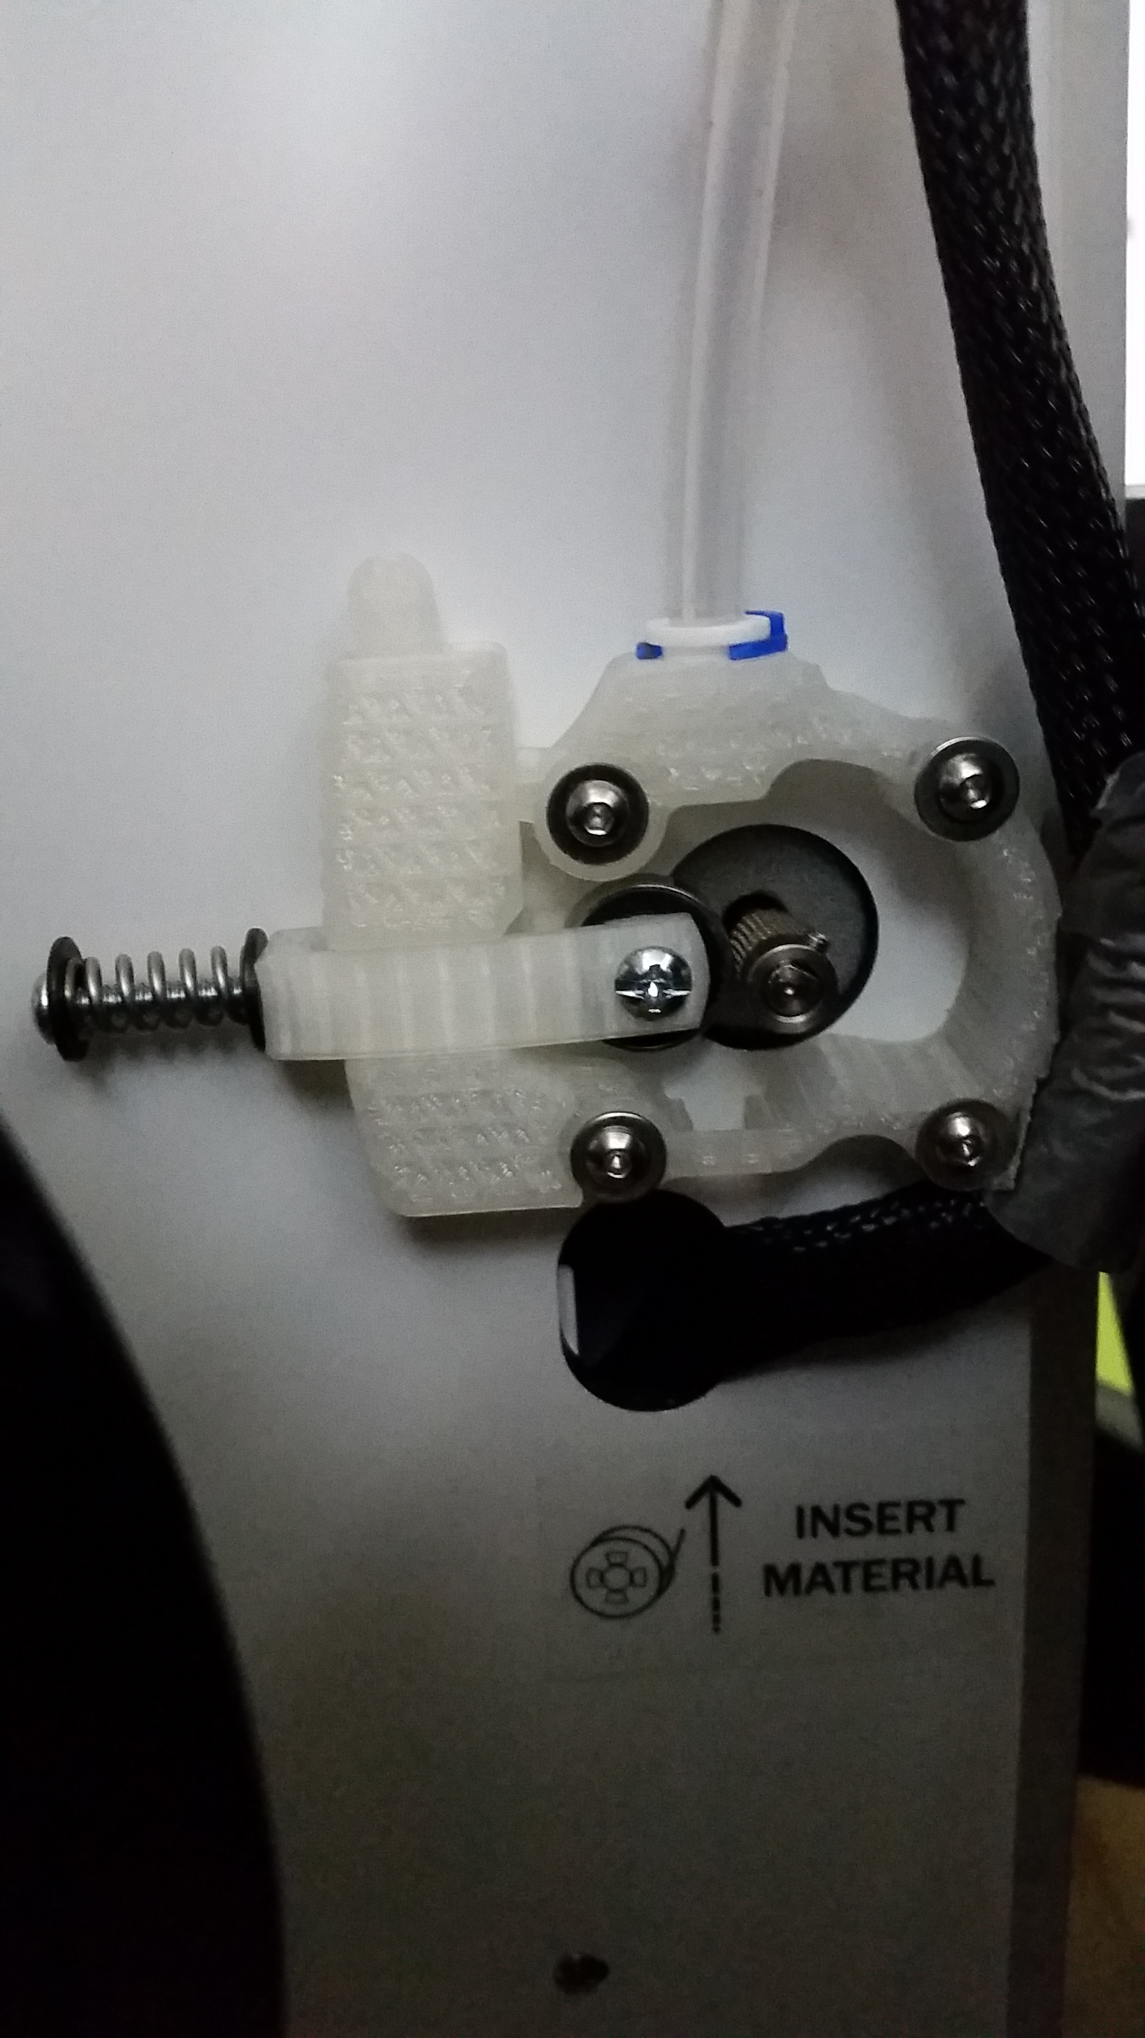

**Figure 3:** Alternate Ultimaker Feeder.

1. **My *Goals* for next week**

* Make even more version 4 magnetic sliders, magnets just came in yesterday!
* Work with Arun on both of our demonstrations.

1. **What I need Dr. Becker to do:**

Time Sheet: (Zoom in to read)

